Home Automation System for controlling room temperature for rural areas of Bangladesh

Md. Borhan Uz Jamil 1,Shutirtha Roy 2, Asif Rezwan Kabir3

Department of Computer Science and Engineering BRAC UniversityDhaka, Bangladesh

[1md.borhan.uz.jamil@g.bracu.ac.bd,](mailto:1shivamttl@gmail.com) [2sutirtha.roy@g.bracu.ac.bd,](mailto:2mannishh96@gmail.com) 3asif.rezwan.kabir@g.bracu.ac.bd

***Abstract*—Being a third-world country, Bangladesh used to have a huge shortage of electricity. In recent times, better and more efficient technology has allowed us to increase our production significantly. However, load shedding is still a common issue in the rural areas, and some areas do not even have electric supply to begin with. We started our project with an aim to minimize this issue through the usage of home automation technology. We created an Arduino based heat and humidity detection system that will turn on fans after the weather crosses a certain threshold. Our project is extremely easy to implement even for the rural people who are not very knowledgeable about technology, and it is constructed using very cheap products. Through this, we hope to reduce unnecessary energy loss where electricity is already rare, and introduce low cost electricity to places where the national power supply grid has not reached yet. Many projects are already in place to tackle the electricity issue. We hope to build on the existing ideas and create a sustainable system that will ensure less electricity wastage and at a minimum price point which will have an overall positive effect on our rural society.**

***Keywords—Shortage, automation, Arduino Uno, Temperature and Humidity Sensor, automation.***

1. Introduction

The number of previous cases of load shedding all over Bangladesh has caused widespread suffering of the Rural people since 1971. Nowadays, load shedding is still common in rural areas in contrast to the cities for that reason the people are not getting enough technology labor for agriculture purpose, household purpose, business purpose and also forcing them to shift to urban areas. For this purpose, we have been focusing on building inexpensive and easy to use home automation systems which we will describe in our methodology part. Till now the previous works about home automation were built for urban areas only, due to which rural areas were abundant. For this purpose, we are trying to make home technology less costly in a handy way for the rural people. Ideally, the technologies used in rural areas are manually built and are not responsive enough due to any accidents like short circuits issues. Also, due to the carelessness of turning off their electrical appliances which costs huge wastes of electricity and for that the people have to face load shedding problems. Therefore, we have decided to build a system which will prevent any type of electricity accidents and automate the system which will be easier to use and will make sure to turn off the system when it is not required [1]. Furthermore, we will discuss the system in the methodology part and will also show the algorithmic architecture. The system will be easy to use as it would automatic the process for the less educated rural people. Also, the major task is to start the system whenever the temperature increases at a certain point and further raise an alarm with the help of led and buzzer if the temperature reaches too far.

1. LITERATURE REVIEW

In a country like Bangladesh, the summers are extremely hot and humid. Sometimes the temperature rises to unbearable levels and people start falling ill, especially the young ones. The majority of the population cannot afford expensive air conditioning, and some houses do not even have fans. Our project tries to implement a solution for such people and provide an affordable alternative to air conditioning. The solution works by turning on the motor when the temperature and humidity are high and also the LED and buzzer are used to warn the user whenever the temperature is too high.The automation only works in areas where people use fans, so it is not beneficial for those who use air conditioners. We have found some previous papers which tried to implement this kind of system but with different types of sensors like bluetooth based sensor**[4]**, wifi/wireless based sensor[7], home sensor network[9], light sensor[3], IOT based sensor[6] and many more. Therefore, in previous research temperature and humidity sensor has not been used along with the conditional logic where along with giving cool air, fire alarm system. Also, it was challenging for this to implement this system and also to find out the better results than previous technologies. Moreover, we could not find much previous research related to lower consumption of electricity whereas we are trying to reduce the wastage of electricity utilization. On the other hand, another model uses more costly sensors to distinguish the fire and they require the internet to send warnings, and to include more, the robot never really stops the fire[11]. Therefore, rural people will be able to use our system at ease since the buzzer and led is included with the project, the two components will just turn on simultaneously when the temperature will increase and will turn off when the temperature will decrease. In this way, the rural people will be able to easily use the components and even repair them due to its non-complex circuitry. Since previous works related to this system do not have automation with temperature and humidity sensors we are trying to get sufficient accuracy and precision from our side by testing it at a different range of temperatures[2].Furthermore, we will be able to reach a successful conclusion after this product has been used over a year where we will be able to know about the success issue. Moreover, our project will save more energy, cheaper and more user friendly which will be helpful for the rural people in Bangladesh.

1. METHODOLOGY

Block Diagram

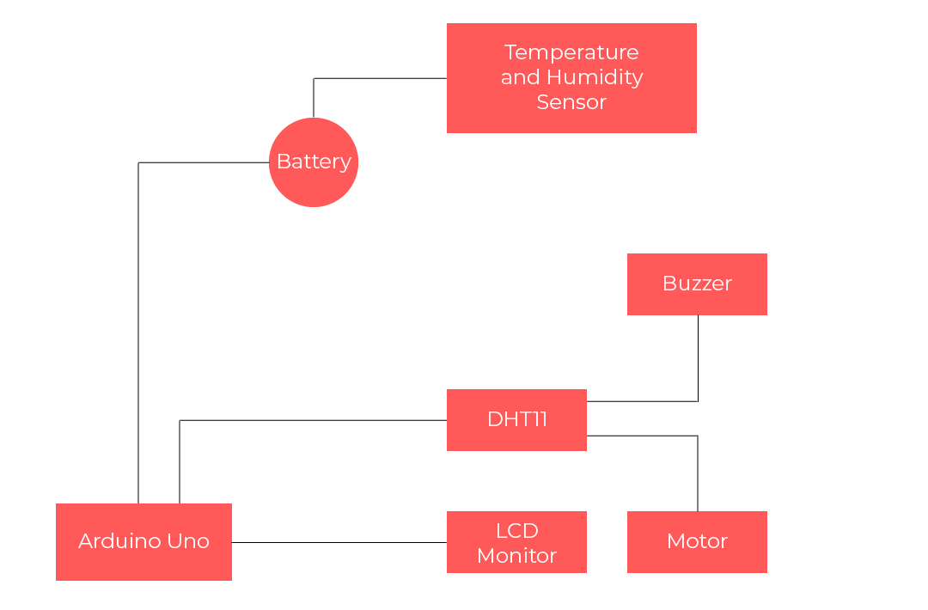

The Arduino Uno and the temperature and humidity sensor(DHT11) is connected to the battery to turn on the device.Also, The LCD monitor, buzzer, led along with the serial monitor is interfaced with the Arduino for showing the outputs. The input is taken from the temperature and humidity sensors and the output based on conditional statements is shown on the other connected devices with arduino.As a result, the outputs of Motor and Buzzer works based on the input of DHT11.

Software Flowchart

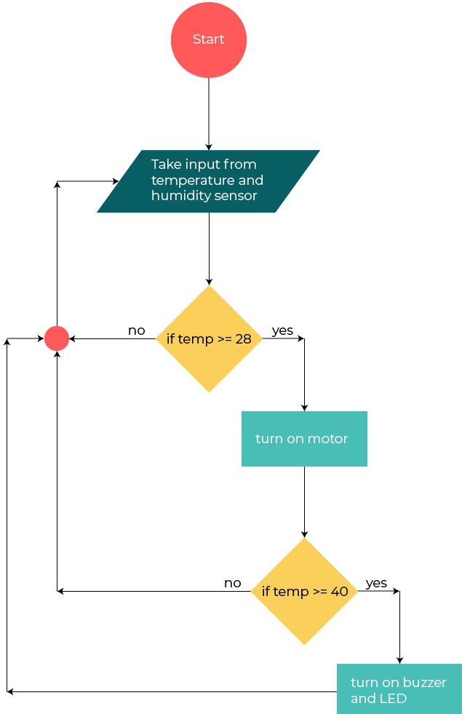

The temperature and humidity sensor takes the data of the temperature and humidity from the room. The humidity and temperature’s value is shown on the serial monitor to get a clear view of the variation of the input. For the whole flowchart only the change of temperature is taken into considering and the humidity is just taken so that the user can see the humidity of the room. Whenever the temperature reaches 28degree Celsius the motor turns on which makes to rotate for fan for lowering the temperature. The reading is continuously taken and the fan keeps rotating unless the temperature drops to 27 degree Celsius. However, if the temperature rises to 40 degree Celsius the buzzer starts as well as the led to warm the user about it. In addition, the buzzer and led keeps working until the temperature becomes less than 40. The reading of temperature and humidity is continuously monitored and repeated without user intervention.

System Architecture

The overall architecture of our system is a very simple variation of a general digital system. It has an input, a micro-controller to process the inputs, and some output devices. Two separate power sources are used to operate the entire system.

Product Architecture and Scalability

The input is a DHT11 temperature and humidity control device that can record the current temperature and humidity in the room. We chose the DHT11 because it provides the exact functionality that we require at the cheapest cost. It is powered by a 9V power source. The feed from the DHT11 is fed into Pin 8 of an Arduino Uno. In the Arduino, the input signal is processed and the temperature and humidity values are stored. Pins 2-7 are used to output the temperature and humidity readings to a LCD display, LM016L. The LCD display is powered through the same 9V battery that is used to power the temperature sensor and the Arduino. The LM016L is the smallest and least expensive LCD we could find that had enough screen space to show both temperature and humidity simultaneously. Furthermore, it operates at very low voltages, so does not consume too much of the power.

For the main processing of our system we decided to choose an Arduino Uno. The reason behind choosing this particular version was its compact size and processing power. Since there are not any complex calculations involved in the project, the basic Arduino was more than enough to handle all the tasks. Further, it had just enough I/O ports to maintain a connection with all the other external modules. If in the future we decide to add more modules to our system, we can upgrade to an Arduino Mega.

The Arduino Uno constantly analyzes the temperature readings from the DHT11. If the readings rise above 28° C, the Arduino sends a signal to a four-channel motor driver module, the L293D through Pins 9 and 10. The L293D is powered through a separate 9V power source. The OUT1 and OUT2 Pins of the driver are connected to the two ends of a simple DC motor. The DC motor is used to control a fan, which will start spinning when the temperature of the room becomes too hot. Instead of using a simple switch to turn the fan on and off, we implemented this logical circuit in an attempt to save electricity. In the rural areas where we are planning to setup our system, the temperature falls to around 20° C during the night. Having an automated system to turn the fan off when the temperature reaches comfortable levels will be able to save electricity almost half of the night.

With more and more technological advantage, the rural areas are starting to use more electrical devices. Furthermore, the clay stoves they use for cooking use dry branches which are extremely flammable. After considering all these reasons, we decided to setup a very low cost fire alarm system that will warn citizens in case a fire starts. To implement this, we connected Pins 12 and 13 to a red LED and a buzzer respectively. When the Arduino receives a very high temperature reading such as 40°, it sends a signal to the buzzer and LED. The buzzer we chose can produce a very loud sound that can wake up the residents even during the nights. The LED is implemented to add a level of visual warning, and also provide some light during the confusion caused by a fire.

Software

For the software simulation, we decided to use Proteus to create a diagram of the circuit. Using Proteus, we were able to run simulations by changing temperature and humidity values. This allowed us to test different weather conditions and find out the reliability of our system through a range of situations.

In the software model of the system, we added a virtual terminal module that gave a constant temperature and humidity update during the circuit’s simulation process. This allowed us to keep track of when the system is functional and also to make calculations to find out the overall accuracy of the system.

After creating the project in Proteus, we decided to use Autodesk Fusion 360 to create a 3D model for our diagram. The user friendly UI and a large library of different resources inspired us to choose it over other alternatives. Furthermore, it had lower system specification requirements and was compatible with our computers.

Modular Development

We have used some modules that are used to show the output for our expected purposes. We will explain all the modules that why have we used and for what reason we have used the module. We have used the following modules:

1) Temperature and Humidity Sensor

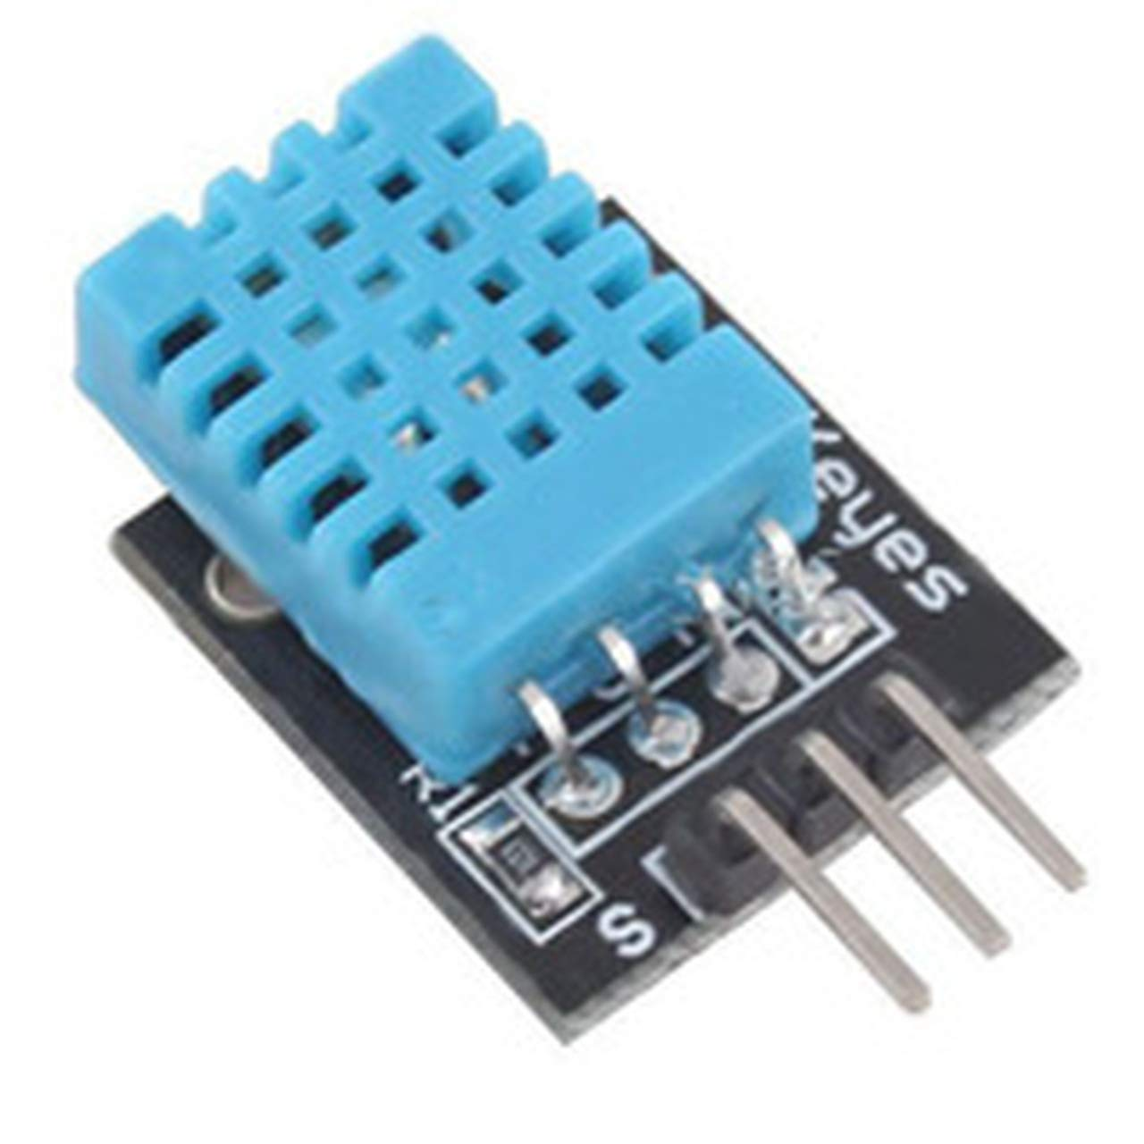

Firstly, DHT11 is an ultra-low-cost digital temperature and humidity sensor. For visualizing the temperature, LM016L a character based LCD motor is used to show the input of temperature and humidity then DHT11.

2) ELECTRIC MOTOR

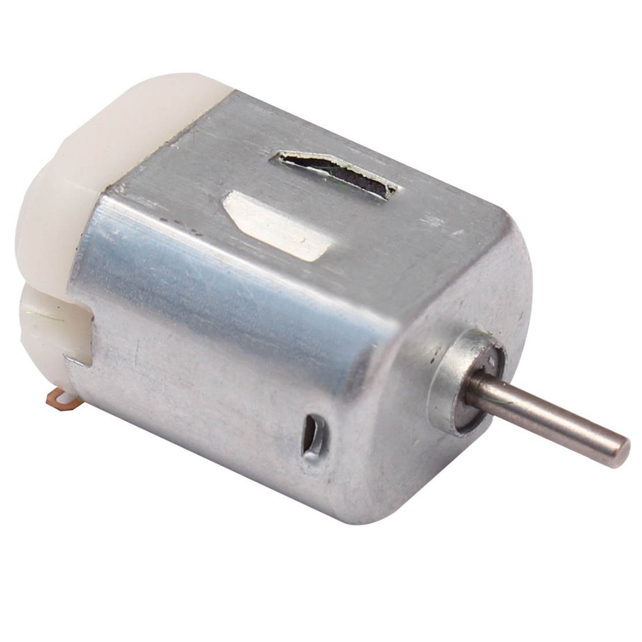

The motor was used to rotate the fans and whenever the temperature became equal or more than 28°C, the motor would turn on.

3) BUZZER

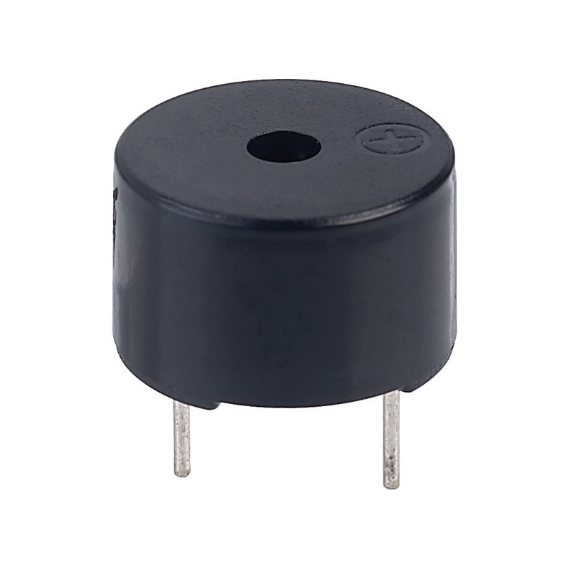

The buzzer to alert the users using a beeping sound. In addition, the buzzer would turn on when the temperature became equal or more than 40°C.

4) LED-RED

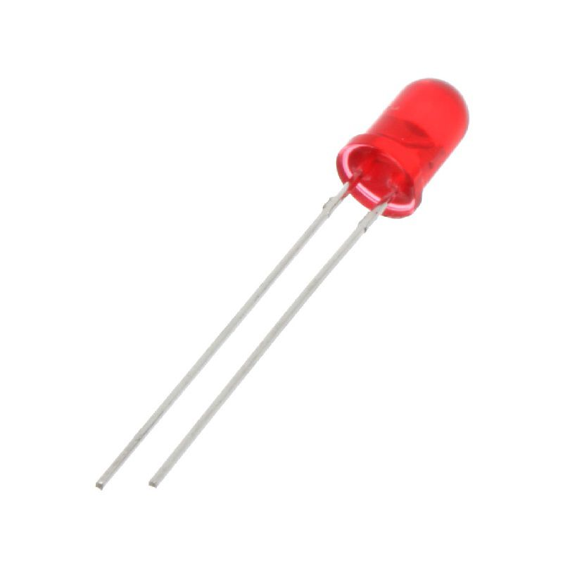

The buzzer to alert the users by lighting up. In addition, the led would light up when the temperature became equal or more than 40°C.

5) L293D: 16-Pin Motor Driver IC

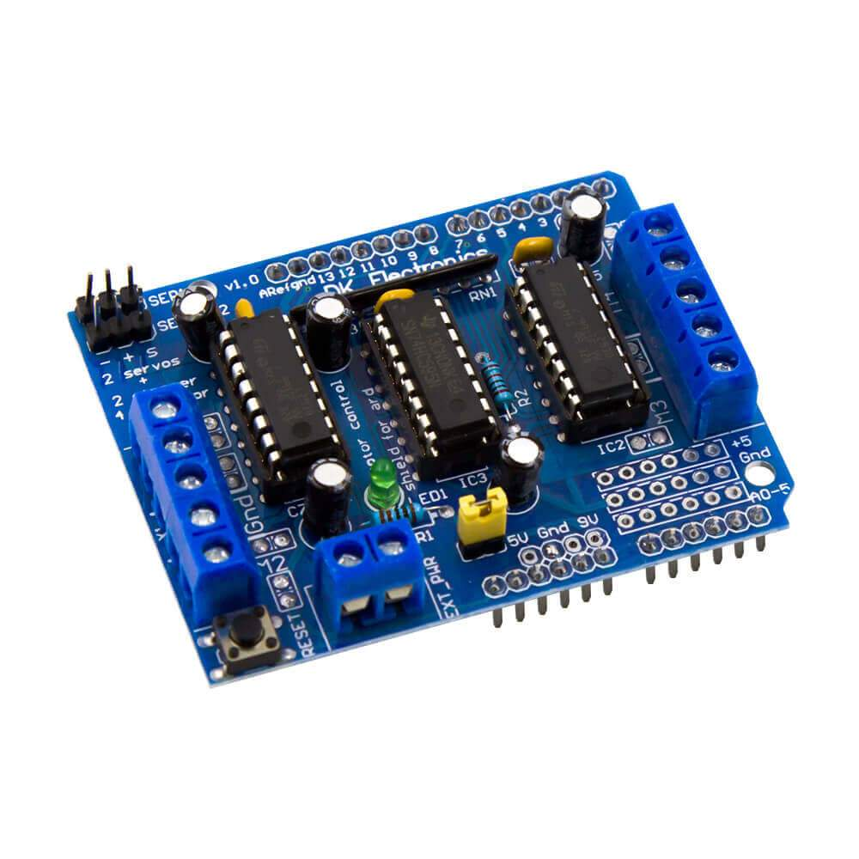

The L293D is used to drive bi-direction currents and designed to drive high-voltage loads in positive supply applications. It is used for:

1. ULN2803 :high-voltage and high-current Darlington transistor array

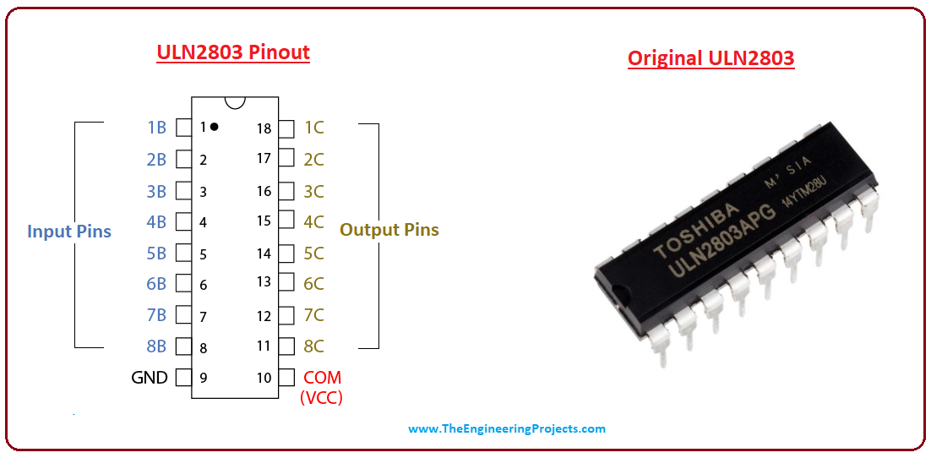

ULN2803 is a high-voltage transistor array and is mainly used as a relay driver with an ability to handle 8 relays at a time.

1. RESULT

Measurement & data analysis(Shutirtha Roy)

Table I

The relationship between Motor State and Temperature(in °C)

|  |  |
| --- | --- |
| Temperature(in °C) | Motor State |
| 16 | OFF |
| 20 | OFF |
| 24 | OFF |
| 28 | ON |
| 32 | ON |
| 36 | ON |
| 40 | ON |
| 44 | ON |
| 48 | ON |
| 52 | ON |

The following temperature data is taken in Table I to determine the states of the motor and it was found that the motor turned on when the temperature was 28 °C.

Table II

The relationship between Buzzer & Led State and Temperature(in

°C)

|  |  |
| --- | --- |
| Temperature(in °C) | Buzzer & Led State |
| 16 | OFF |
| 20 | OFF |
| 24 | OFF |
| 28 | OFF |
| 32 | OFF |
| 36 | OFF |
| 40 | ON |
| 44 | ON |
| 48 | ON |
| 52 | ON |

The following temperature data is taken in Table I to determine the states of the buzzer & led and it was found that the buzzer & led turned on when the temperature was 28 °C.

GRAPH (SHUTIRTHA)

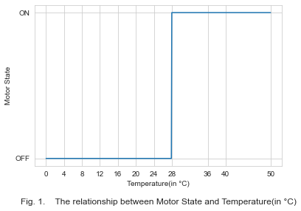

From the following figure 1. we can determine the relationship between the motor state and the temperature. Over here, the state of the motor remains off until and unless the temperature reaches to 28 °C. In addition, the motor keeps rotation by staying at open state, and turns off when the temperature again decreases less than 28 °C. This step is repeated every time the input is taken and vice versa.

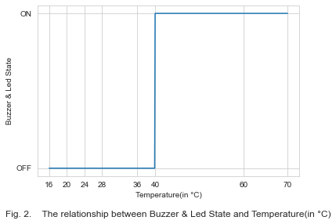

From the following figure 2. we can determine the relationship between the buzzer & led state and the temperature. Over here, the state of the buzzer and led stays off until and except if the temperature ranges to 40°.In addition, the buzzer makes a alarming sound and led lights up at open state, and turns off when the temperature again diminishes under 40°C.This advance is taken each time the input of the temperature is taken.

CHART

ACCURACY

Fig 3. Accuracy comparison of all the existing products along with our products

SUMMARY

Our objective was to collect the experimental data to compare with the rural temperature with the help of our sensor by interfacing with the Arduino along with other components like motor and buzzer & led. The data was collected using the instrument DHT11 from where the reading of temperature and humidity were taken. Additionally, the reading of the data was taken at 20°C when both the motor and the buzzer & led were turned off. The data was collected by increasing the temperature by 4°C to check whether any of the instruments started working or not. In this way, the motor state turned on when the temperature reached 28°C and remained in ON state as we increased the temperature. In addition, the buzzer & led turned ON when it reached 40°C, and remained on as we increased the temperature. After both of the instruments started working we started to decrease the temperature to see if the instruments turned off at the same instance as they turned ON. Therefore, we found buzzer & led to remain at OFF state when the temperature is less than 40°C and the motor to remain at OFF state when the temperature is less than 28°C. There were many previous similar projects but it did not have a temperature and humidity sensor, so it was hard to compare accuracy with previous papers. We have tried our products for 50 times and got expected results 44 times. Since it is a fully new based sensor based project, the accuracy can be developed in the near future. For future work, we would like to develop our project by adding new functions for more automation purposes.

1. Conclusion

This paper has discussed the methodology used to ensure the safety of rural people and to reduce the waste of using electricity. It can be done using sensors to study the temperature and taking planned measures. Our project is made with low and affordable costs for users. The design is mainly done for rural people because most of them are so careless about the safety issue when they are using electricity.. Particularly, it will be of great use for people because of this project's good build quality at a ver low price.To do this project there were some difficulties because of the shortage of enough resources and also we were not able to implement it practically which has made confusion to get a good accuracy rate. So it would be great if we got the chance to test it in real environment.We are thinking about developing the system in the near future by adding more sensors like smoke sensor and making it more suitable to use it in industrial sector. We think our project will bring a great change in rural people's lives which will influence us to develop our project more efficiently in the future.

References

[1] K. Agarwal, A. Agarwal, and G. Misra, “Review and performance analysis on wireless smart home and home automation using IoT,” in 2019 Third International conference on I-SMAC (IoT in Social, Mobile, Analytics and Cloud) (I-SMAC), 2019, pp. 629–633.

[2] S. Ivanović, S. Milivojša, T. Erić, and M. Vidaković, “Collection and analysis of system usage data in smart home automation systems,” in 2017 IEEE 7th International Conference on Consumer Electronics - Berlin (ICCE-Berlin), 2017, pp. 65–66.

[3] B. Gokaraju, D. Yessick, J. Steel, D. A. Doss, and A. C. Turlapaty, “Integration of intrusion detection and web service alarm for home automation system using ‘ARM’ microprocessor,” in SoutheastCon 2016, 2016, pp. 1–2.

[4] J. Ding, Y. Sheng, C. Tu, C. Huang, and J. Su, “The management of device group for home automation network,” in 2010 Fifth International Conference on Digital Telecommunications, 2010, pp. 44–47.

[5] S. M. Brundha, P. Lakshmi, and S. Santhanalakshmi, “Home automation in client-server approach with user notification along with efficient security alerting system,” in 2017 International Conference On Smart Technologies For Smart Nation (SmartTechCon), 2017, pp. 596–601.

[6] T. Chaurasia and P. K. Jain, “Enhanced smart home automation system based on internet of things,” in 2019 Third International conference on I-SMAC (IoT in Social, Mobile, Analytics and Cloud) (I-SMAC), 2019, pp. 709–713.

[7] C. Tseng, C. Cheng, Y. Hsu, and B. Yang, “An IoT-based home automation system using WI-fi wireless sensor networks,” in 2018 IEEE International Conference on Systems, Man, and Cybernetics (SMC), 2018, pp. 2430–2435.

[8] N. Vikram, K. S. Harish, M. S. Nihaal, R. Umesh, and S. A. A. Kumar, “A low cost Home Automation System using WI-Fi based Wireless Sensor Network incorporating internet of things (IoT),” in 2017 IEEE 7th International Advance Computing Conference (IACC), 2017, pp. 174–178.

[9] J. Zhang, G. Song, H. Wang, and T. Meng, “Design of a wireless sensor network based monitoring system for home automation,” in 2011 International Conference on Future Computer Sciences and Application, 2011.

[10] T. Gabriele, L. Pantoli, V. Stornelli, D. Chiulli, and M. Muttillo, “Smart power management system for home appliances and wellness based on wireless sensors network and mobile technology,” in 2015 XVIII AISEM Annual Conference, 2015, pp. 1–4.

[11] R. C. Luo and K. L. Su, "Autonomous Fire-Detection System Using Adaptive Sensory Fusion for Intelligent Security Robot," in *IEEE/ASME Transactions on Mechatronics*, vol. 12, no. 3, pp. 274-281, June 2007.